Media: For more information, contact SeaWorld Public Relations at (619) 226-3929.
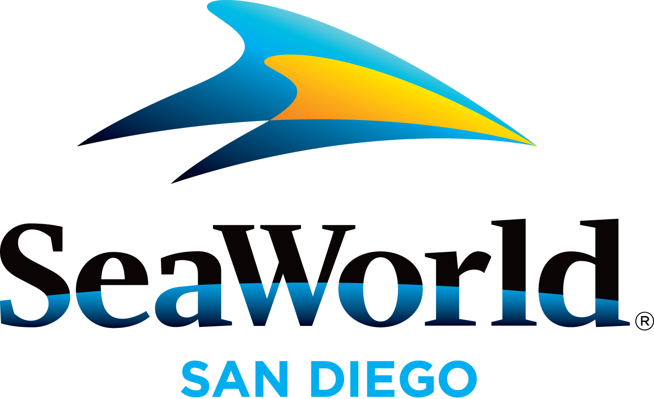

SEAWORLD TO DELIVER BOATLOADS OF FUN IN 2015

SeaWorld® San Diego has a boatload of reasons to visit the marine park in 2015, and will start off by ringing in the Lunar New Year with an all-new celebration in February; next, animal lovers will delight in Wild Days for four weekends in March (with one weekend featuring conservationist Jack Hanna); kids and kids-at-heart can enjoy Breakfast With Elmo and Friends in March; and foodie and craft beer aficionados will find tasty delights throughout the park during SeaWorld’s inaugural Seven Seas Food Festival in May. Plus, back are SeaWorld’s traditional seasonal favorites including Summer Nights, Halloween Spooktacular® and Christmas Celebration®. All in all, there’s a whale-sized list of reasons to visit SeaWorld all year long. Seasonal events are included with park admission, but the best way to enjoy all the fun is to purchase a Fun Card, which allows guests to return over and over, all for the price of a single-day admission!
New in 2015!
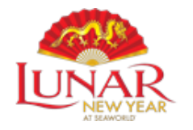
In keeping with the Chinese tradition of wishing good fortune and happiness to family and friends, the marine park will celebrate with Lunar New Year at SeaWorld, Feb. 13–16, 21–22 and Feb. 28–March 1. SeaWorld’s Festival Village will feature Asian-inspired culinary offerings and a community stage presented by Coca-Cola* featuring cultural performances celebrating Asia, such as taiko drummers and fan dancers. Also, the Chinese Acrobats of Hebei will perform 25-minute shows at Mission Bay Theater. And, each guest will receive a red envelope with a special gift inside. *Coca-Cola is the official refreshment beverage of SeaWorld Parks & Entertainment.
Guests can celebrate the natural world we share during SeaWorld Wild Days, getting up-close with SeaWorld’s zoological team and learning firsthand the ways they can make a difference with their own everyday actions. During the March
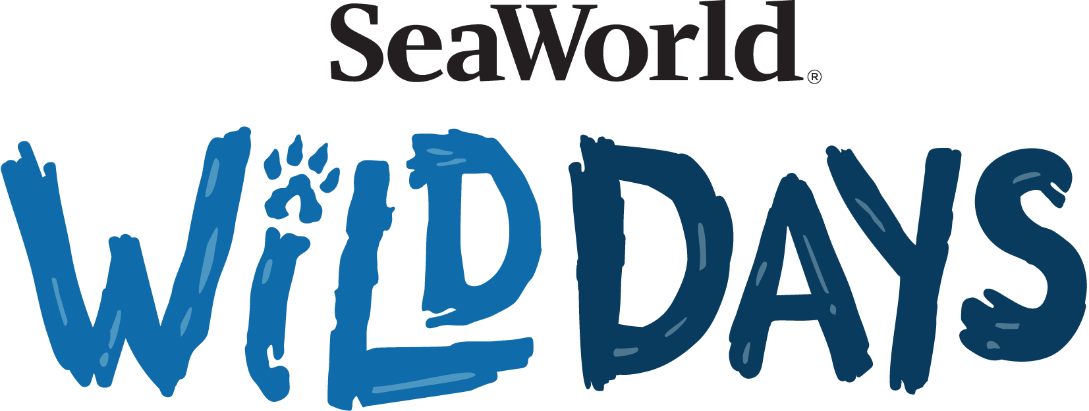
7–8 weekend, animal conservationist Jack Hanna and SeaWorld and Busch Gardens Animal Ambassador Julie Scardina will introduce amazing animals; March 14–15 is “Sea Rescue” weekend, with SeaWorld® team members from
the popular ABC show sharing stories of the rescue, rehabilitation and return to the wild of marine animals; March 21-22 and March 28-29 are Generation Nature™ (GenN) weekends, featuring high-energy, fun-filled shows packed with cool animal facts designed to inspire kids to become game changers for nature.
Families will have a chance to join some of their favorite furry friends during Breakfast with Elmo and Friends, offered March 21-22 and March 28-29 and weekends July 18 through Aug. 2. Diners may start their day with a delicious breakfast buffet that features mini pancakes, eggs, bacon, steel cut oatmeal, fresh fruit and much more. On top of that, guests may get a full serving of hugs and giggles from everyone's favorite Sesame Street friends as they laugh and linger at tables. This experience plus tax, gratuity and park admission, is $19.99 for ages 10 and older ($14.99 ages 3–9) those under 3 are free with a reservation. To learn more or make reservations call (888) 255-1143 or visit SanDiegoSeaWorldTickets.com/dining.html.

Foodies and craft beer aficionados are going to love SeaWorld Seven Seas Food Festival, featuring craft beer from Stone Brewing Co. and other local breweries, plus international cuisine representing California fusion, Europe, the Caribbean and Pacific Islands. Wine will also be served and local bands will perfor0m throughout the day at Garden Plaza. Dates are: May 2–3, 9–10, 16–17 and 23–24.
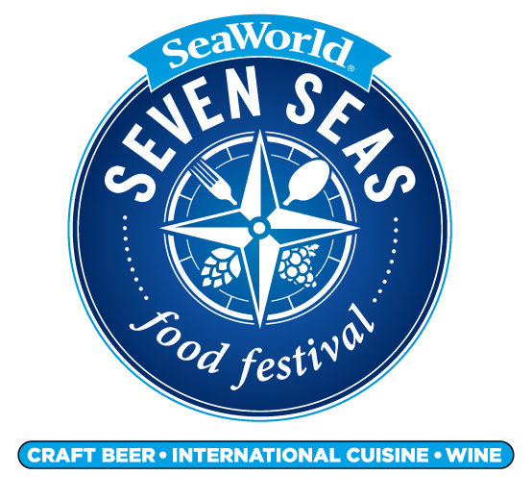

SeaWorld® reverberates with vibrant, nationally recognized performers—some from acclaimed television competition shows—in SeaWorld’s Summer Vibes presented by Coca-Cola, a series of performances Thursdays through Mondays July 16–Aug. 30 in the park’s Mission Bay Theater. Kicking off the series will be the COMPANY MEN, a mashup group that interweaves hits from the last six decades of music, moving seamlessly between the greatest classic hits and Top 40 on the radio today (July 16–20). Next up is The Filharmonic, a group of Filipino-American youngsters offering an urbanesque hip-hop sound with a ’90s nostalgic flavor. Featured as semi-finalists on NBC’s musical competition show “The Sing-Off” and appearing in the hit film “Pitch Perfect 2,” The Filharmonic will perform at SeaWorld July 23–27. Stay tuned for more Summer Vibes act announcements.

SeaWorld Favorites Return in 2015
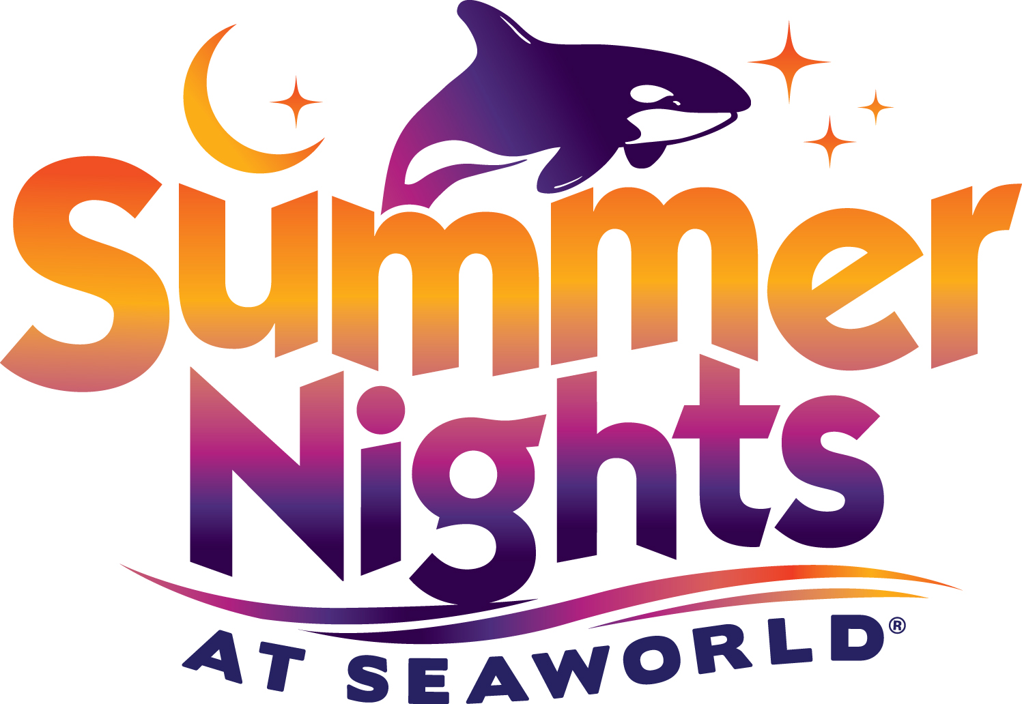
Guests can enjoy Turtle Reef™, Manta® and all their favorite SeaWorld® attractions by day and then stay late to take in Summer Nights (select dates May 23–Sept. 7), featuring fireworks, nighttime animal shows, Shamu’s Celebration: Light Up The Night and Sea Lions Tonite.
During SeaWorld’s Halloween Spooktacular®, kids can show up in costume and enjoy not-too-spooky entertainment such as a Halloween-themed sea lion and otter show, colorful costumed characters and trick-or-treating among a sea-inspired atmosphere. Halloween Spooktacular takes place weekends Sept. 26–Nov. 1.
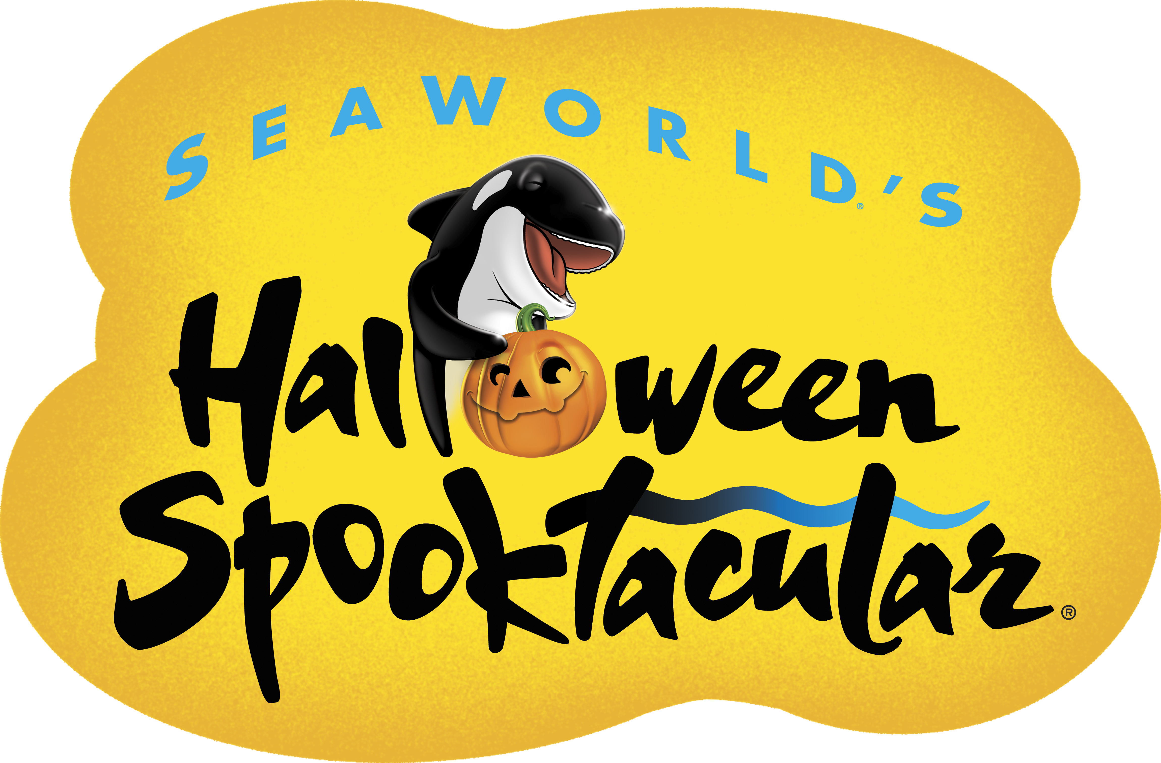

SeaWorld’s Christmas Celebration® returns even bigger and better Nov. 21, 2015–Jan. 3, 2016. Guests can grab hot cocoa and experience shows including the inspiring Shamu Christmas Miracles featuring SeaWorld’s family of killer whales; and the hilarious Clyde & Seamore's Christmas Special. Families can also enjoy the nightly lighting of the 40-foot animated tree and more.
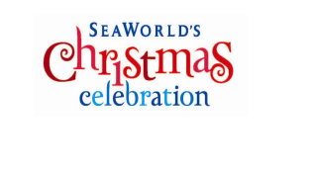
SeaWorld® is open year-round including holidays. Parking is $16; $11 for motorcycles; $21 for RVs and up-close. Admission is $86 for ages 10 and older; $80 for ages 3–9; free for under 3. Guests may enjoy all of SeaWorld’s seasonal offerings in 2015 by purchasing a Fun Card, allowing them to visit the park over and over for the same price as a single-day admission. Park hours vary by season. Visit www.SeaWorldSanDiego.com or call (800) 257-4268 for hours and information.

About SeaWorld:
SeaWorld Entertainment, Inc. (NYSE: SEAS) is a leading theme park and entertainment company delivering personal, interactive and educational experiences that blend imagination with nature and enable its customers to celebrate, connect with and care for the natural world we share. The Company owns or licenses a portfolio of globally recognized brands including SeaWorld®, Shamu® and Busch Gardens®. Over its more than 50-year history, the Company has built a diversified portfolio of 11 destination and regional theme parks that are grouped in key markets across the United States, many of which showcase its one-of-a-kind zoological collection of approximately 89,000 marine and terrestrial animals. The Company’s theme parks feature a diverse array of rides, shows and other attractions with broad demographic appeal which deliver memorable experiences and a strong value proposition for its guests.
SeaWorld Entertainment, Inc. is one of the world’s foremost zoological organizations and a global leader in animal welfare, training, husbandry and veterinary care. The Company collectively cares for what it believes is one of the largest zoological collections in the world and has helped lead advances in the care of animals. The Company also rescues and rehabilitates marine and terrestrial animals that are ill, injured, orphaned or abandoned, with the goal of returning them to the wild. The SeaWorld rescue team has helped more than 24,000 animals in need over the last 50 years.
Additional information about SeaWorld Entertainment, Inc. can be obtained online at www.SeaWorldEntertainment.com. Shareholders and prospective investors can also register to automatically receive the Company's press releases, SEC filings and other notices by email by registering at that website.

—SeaWorld—

Updated: July 2015

