Media: For more information, contact SeaWorld/Aquatica Public Relations at (619) 226-3929.

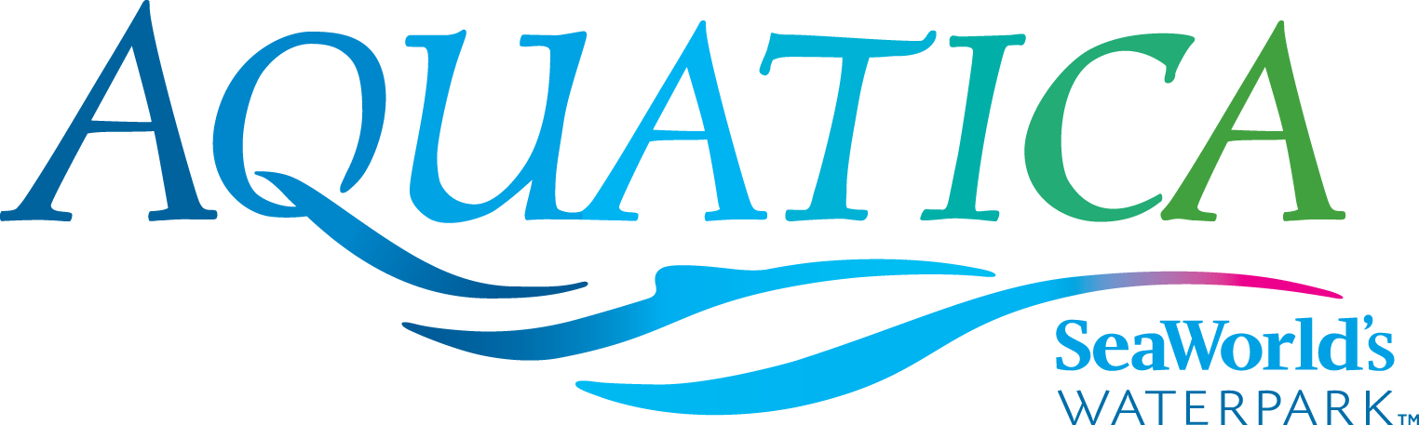

TAUMATA RACER IS A GUEST FAVORITE AT AQUATICA SAN DIEGO

SAN DIEGO (May 8, 2015) -- For those who prefer life in the fast lane, Taumata Racer® is just the ticket! This high-speed racing water slide at Aquatica SeaWorld’s WaterparkTM zooms riders down a 375-foot slide, around a 180-degree swooping turn, and in and out of tunnels before racing them across the finish line. Taumata Racer, located between Walhalla Wave® and Kata’s Kookaburra Cove® on the northwest side of the park, is one of Aquatica’s fastest slides and has a minimum height requirement of 42 inches.
“Taumata Racer is definitely a fan favorite at Aquatica,” said David Cromwell, the waterpark’s vice president. “This mat-racer water slide is a unique blend of competitive racing and high-speed thrills. It is a welcome addition to the park (Taumata Racer debuted in 2014) and certainly an experience that families and friends can enjoy together. This is exactly the type of attraction that makes Aquatica an even more exciting waterpark.”
Taumata Racer, manufactured by ProSlides of Ontario, Canada, features six side-by-side lanes. Park guests speed down the steep hill (60 feet) on a mat head first. The minimum height requirement is 42 inches.
Taumata Racer is as memorable for its fun and excitement as it is for its name. Named for a famous hill in New Zealand, Taumata is short for the 85-letter Maori word “Taumatawhakatangihangakoauauotamateaturipukakapikimaungahoronukupokaiwhenua-kitanatahu.” Roughly translated, this Guinness Book of World Records word means “The summit where Tamatea, the man with the big knees, the climber of mountains, the land-swallower who traveled about, played his flute to his loved one.”
Aquatica San Diego, a lushly landscaped waterpark, combines up-close animal experiences, high speed thrills and the amenities of a beachside resort. Among dozens of slides and rides at this whimsical, South Seas-themed waterpark is Big Surf Shores, one of the largest wave pools in Southern California, and Loggerhead Lane where guests can float in an inner tube along a 1,250-foot lazy river. New this year, all of the resort pools and children’s attractions are heated to 78-80 degrees (this includes Big Surf Shores, Loggerhead Lane, Kata’s Kookaburra Cove®, Walkabout Waters and Slippity Dippity). Caribbean flamingos and freshwater turtles round out the Aquatica experience, as only SeaWorld® can.
Aquatica is located at 2052 Entertainment Circle in Chula Vista, California. Operational dates for 2015 are May 23–25; daily May 30–Sept. 7; Saturdays and Sundays, Sept. 12–27. Single-day admission is $42 for ages 10 and older; $36 for ages 3–9. Season Passes cost $42 (and do not include parking); a premium season Aquatica Pass costs $89. Memberships for both SeaWorld San Diego and Aquatica San Diego are available and start at $215. For more information visit www.AquaticaSanDiego.com or call (800) 257-4268.
SeaWorld Entertainment, Inc. (NYSE: SEAS) is a leading theme park and entertainment company delivering personal, interactive and educational experiences that blend imagination with nature and enable its customers to celebrate, connect with and care for the natural world we share. The Company owns or licenses a portfolio of globally recognized brands including SeaWorld®, Shamu® and Busch Gardens®. Over its more than 50-year history, the Company has built a diversified portfolio of 11 destination and regional theme parks that are grouped in key markets across the United States, many of which showcase its one-of-a-kind zoological collection of approximately 89,000 marine and terrestrial animals. The Company’s theme parks feature a diverse array of rides, shows and other attractions with broad demographic appeal which deliver memorable experiences and a strong value proposition for its guests.
SeaWorld Entertainment, Inc. is one of the world’s foremost zoological organizations and a global leader in animal welfare, training, husbandry and veterinary care. The Company collectively cares for what it believes is one of the largest zoological collections in the world and has helped lead advances in the care of animals. The Company also rescues and rehabilitates marine and terrestrial animals that are ill, injured, orphaned or abandoned, with the goal of returning them to the wild. The SeaWorld rescue team has helped more than 24,000 animals in need over the last 50 years.
Additional information about SeaWorld Entertainment, Inc. can be obtained online at www.SeaWorldEntertainment.com. Shareholders and prospective investors can also register to automatically receive the Company's press releases, SEC filings and other notices by email by registering at that website.

—Aquatica—

