News Media
Tip Sheet

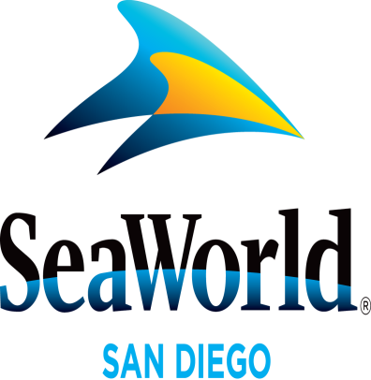

JULY 2015
SEAWORLD SALUTES MARINES AT ITS ONE OCEAN SHOW: For the past 13 years, SeaWorld® San Diego has been honoring the men and women of the U.S. armed forces through the park’s Waves of Honor program. Waves of Honor provides active-duty military and three members of their immediate family with complimentary admission each year. The park also acknowledges active-duty service members and veterans prior to each One Ocean killer whale show. In keeping with the spirit of SeaWorld’s appreciation of their service, during the month of July the park will pay tribute to 31 active-duty Marines from MCAS Miramar who have maintained exceptional service records. One Marine each day will stand in uniform, while killer whale trainers recognize their dedication, bravery and sacrifice in front of thousands of park guests during a One Ocean preshow.
SEAWORLD’S FOURTH OF JULY BLAST: SeaWorld® will celebrate Independence Day with a number of festivities: the day will start with a Fourth of July Flag Ceremony at the marine park’s Circle of Flags. Just before the park opens, the Camp Pendleton Marine Corps Color Guard will participate in a patriotic flag-raising salute. Capping off the park’s Summer Nights at SeaWorld celebration, the Sea to Shining Sea Fireworks Spectacular will light up the night sky with an extended display at 10:30 p.m. Guests wishing for an exclusive experience can purchase SeaWorld’s VIP fireworks experience with special seating at Cirque Stadium overlooking Mission Bay. Each package includes a glow wand, dessert box and a pre-firework concert by SeaWorld’s own Sea Street Band. Guests can purchase this exclusive experience for $14.95 on sale now only at SeaWorld San Diego. Portions of the proceeds will be donated to Hubbs-SeaWorld Research Institute. SeaWorld is open until 11 p.m. on July 4. For show schedules and more information visit www.SeaWorldSanDiego.com.
BEAT THE HEAT AT AQUATICA: With rising summer temperatures throughout the season, Aquatica SeaWorld’s WaterparkTM has plenty of ways to keep guests cool. Among lushly landscaped attractions with high-speed thrills and the amenities of a beachside resort at this whimsical, South Seas-themed waterpark is Taumata Racer®. Rising nearly 60 feet above the ground, Taumata Racer zooms riders face down on mats 375 feet through one of six translucent tubes, around a 180-degree swooping turn before they cross the finish line in rainbow-hued lanes. Other slides and attractions at Aquatica include Big Surf Shores, a large wave pool with more than 500,000 gallons of water and an expansive sandy beach; and HooRoo Run®, where adventurers zoom down an 80-foot descent. On days where the temperature is a little cooler, Aquatica now features heated pools! All of the children’s attractions, plus Big Surf Shores and Loggerhead Lane are kept at a comfortable 78- to 82-degree temperature. Aquatica also features up-close encounters with Caribbean flamingos and freshwater turtles. Aquatica is open daily through Aug. 31 and weekends only Sept. 5-27. For more information, visit www.AquaticaSanDiego.com.
BREAKFAST WITH ELMO AND FRIENDS: Sesame Street® lovers are sure to enjoy Breakfast with Elmo and Friends, 9 to 10 a.m. weekends July 11 through Aug. 2. Diners may start their day with a delicious breakfast buffet that features mini pancakes, eggs, bacon, steel cut oatmeal, fresh fruit and much more. On top of that, guests may get a full serving of hugs and giggles from everyone's favorite Sesame Street friends as they laugh and linger at tables. This experience plus tax, gratuity and park admission, is $19.99 for ages 10 and older ($14.99 ages 3–9) those under 3 are free with a reservation. To learn more or make reservations visit SanDiegoSeaWorldTickets.com/dining.html
Photos and videos are available upon request. For more information, please contact SeaWorld®
Public Relations at (619) 226-3929, or visit the online Media Room at www.SeaWorld.com/sdpressroom.

—SeaWorld—

