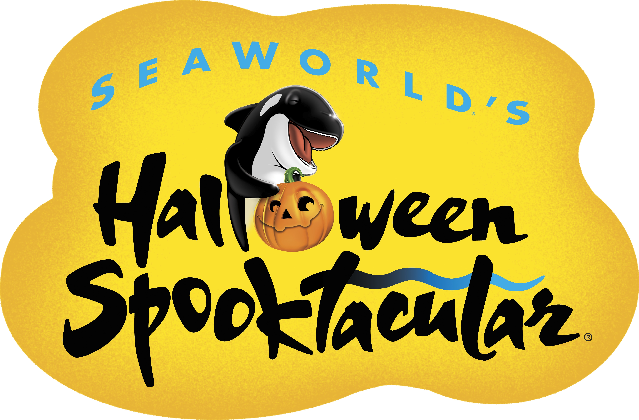

Media: For more information, contact Kat Marin in Public Relations at (619) 226-3614.

THE SPELL HAS BEEN CAST; HALLOWEEN WILL BE A BLAST

AT SEAWORLD’S HALLOWEEN SPOOKTACULAR!
Plus Kids Can Visit the Park for Free in October

SAN DIEGO (Sept. 8, 2015) – Whoever said that Halloween is just for land dwellers is mistaken! Witches and wizards-in-training can park their broomsticks at SeaWorld’s Halloween Spooktacular®, where fun brews under the sea. Everyone is invited to join in on the anything-but-spooky event, which is included with park admission. And how’s this for a treat without a trick: SeaWorld® is offering one child, aged 3 to 9, free admission with one full-paid adult admission during October, making this family-friendly event even more affordable!
Children 12 and under are encouraged to come in costume and will definitely have a howling good time at this year’s festivities, which has been extended to two additional weekends: Sept. 26-27, Oct. 3-4, Oct. 10-11, Oct. 17-18, Oct. 24-25 and Oct. 31- Nov. 1, 2015.
Superheroes and ninjas can take a break from trick-or-treating among 12 underwater-themed stations and get their bones over to the brand new Clyde & Seamore’s Big Halloween Bash show, where SeaWorld’s prank-loving pinnipeds, California sea lions Clyde® and Seamore®, get their Halloween on, along with the always-mischievous O.P. Otter®. Or, they can zap their way to Mission Bay Theater for Sesame Street’s Who Said Boo?, starring Elmo and his friends as they dress up in their Halloween best to sing and dance their way through Count’s Castle!
Monsters of all sizes can mash at Otto and Penelope’s Pumpkinfish Patch where they can eat, drink and be not-so-scary! This unique and colorful undersea pumpkin patch is the prime location for a multitude of activities and photo opportunities with costume characters. New this year is a Sand Bar, where fun-sized princesses and pirates can let their imaginations run wild and build their own neon green kinetic sand creations. Kids can also decorate their own cookies, paint pumpkins and meet a fantastical cast of characters such as Colonel Cornelius Candy Corn, a spirited explorer, accompanied by Lady Candy Corn.
Never-before-seen characters roaming the Pumpkinfish Patch this year are B-Boy Candy Buttons and Lolly Pop N’ Lockit. Princess Da’vine the Pumpkin Princess, Goodie and Greta Gumdrop and a silly School of Fish will be rocking out to DJs Rock Candy and Cotton Candy, who get the party started and keep it going all day during Halloween Spooktacular, playing music and leading activities. Allure and Capri, the popular and beautiful sister mermaids, spend some time on land in their magical clam shell grotto to meet and greet with guests.
In addition to taking advantage of SeaWorld’s free single-day child ticket with one full-paid adult admission, dads and mummies can unwrap the same offer at Dine With Shamu® where each child dines free with the purchase of a full-paid adult, all at poolside tables near SeaWorld’s family of killer whales. Plus, a child age 10 to 12 can participate for free in SeaWorld’s Dolphin and Beluga Interaction Programs with one full-priced adult participation (children must be at least 48 inches tall to participate in BIP and DIP).
SeaWorld is open year-round including holidays. Parking is $16; $11 for motorcycles; $21 for RVs and Up-Close. Admission is $89 for ages 10 and older; $83 for ages 3–9; free for under 3. Park hours vary by season. Visit www.SeaWorldSanDiego.com or call (800) 257-4268 for hours and information.
About SeaWorld Entertainment, Inc.
SeaWorld Entertainment, Inc. (NYSE: SEAS) is a leading theme park and entertainment company delivering personal, interactive and educational experiences that blend imagination with nature and enable its customers to celebrate, connect with and care for the natural world we share. The Company owns or licenses a portfolio of globally recognized brands including SeaWorld®, Shamu® and Busch Gardens®. Over its more than 50-year history, the Company has built a diversified portfolio of 11 destination and regional theme parks that are grouped in key markets across the United States, many of which showcase its one-of-a-kind zoological collection of approximately 89,000 marine and terrestrial animals. The Company’s theme parks feature a diverse array of rides, shows and other attractions with broad demographic appeal which deliver memorable experiences and a strong value proposition for its guests.
SeaWorld Entertainment, Inc. is one of the world’s foremost zoological organizations and a global leader in animal welfare, training, husbandry and veterinary care. The Company collectively cares for what it believes is one of the largest zoological collections in the world and has helped lead advances in the care of animals. The Company also rescues and rehabilitates marine and terrestrial animals that are ill, injured, orphaned or abandoned, with the goal of returning them to the wild. The SeaWorld rescue team has helped more than 26,000 animals in need over the last 50 years.
Additional information about SeaWorld Entertainment, Inc. can be obtained online at www.SeaWorldEntertainment.com. Shareholders and prospective investors can also register to automatically receive the Company's press releases, SEC filings and other notices by email by registering at that website.

—SeaWorld—

