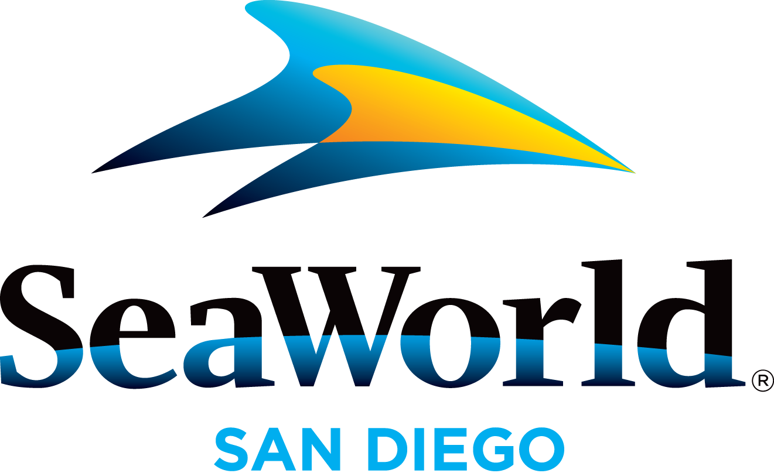

Media: For more information, contact SeaWorld Public Relations at (619) 226-3929.

SEAWORLD SAN DIEGO 2016 MEDIA ADMISSIONS POLICY
The media admissions policy for SeaWorld® San Diego enables news media to become familiar with the park’s many featured attractions and, at the same time, enjoy a day with family or friends. This courtesy is extended to active, credentialed members of the news media only, which does not include administrative, promotions directors, sales staff or retired personnel, writers of corporate or community newsletters, or non-news management. Complimentary admission is available to media in the following categories:
Print Media: Publishers, editors, reporters, writers, photographers Complimentary admission is provided to freelance writers and producers
with written confirmation from the assigning news outlet.
Broadcast Media: News directors, public affairs directors, assignment editors,
producers, on-air personnel (anchors/hosts/DJs/reporters) photographers, program directors
Online Media: Bloggers are considered on a case-by-case basis if the blogger has a significant social media following and meets other criteria. Links to the blog posts must be sent within seven days of the visit to the park.
A maximum of four complimentary tickets will be granted in a six-month period to qualifying personnel. This courtesy is for park admission only.
Arrangements for tickets are made by sending us a written request via email (swcpublicrelations@seaworld.com) from your company email address at least 72 hours in advance of your visit. Please attach your media credential along with your request. To assist us with our conservation efforts, please refrain from sending requests via fax. Requests for weekend days made after noon on Thursday will not be granted. For holidays observed on Mondays, requests should be made by noon the previous Thursday. Your request should include:
- Name and your company title
- The exact date of your visit
- Number of adult and child tickets (ages 3–9) requested (not to exceed four total)
- A contact phone number and an e-mail address
- A copy of your media credential providing proof as a member of the news media

Once your request is received, please allow 48 hours for it to be processed. You should receive an email confirming your visit. Please contact us at (619) 226-3929 if you have not received a confirmation at least 48 hours in advance of your requested visit. For more information on requesting tickets, call (619) 226-3929. Office hours are 8:30 a.m. to 5 p.m. (closed on weekends and holidays).
Media on Assignment: News media on assignment must request interviews and photo sessions in advance. This ensures that appropriate park personnel will be available on the day of the visit. All media on assignment must arrive at the security entrance and be escorted during their visit. Without prior approval, family members and friends will not be permitted to accompany media while on assignment.

—SeaWorld—

