Media: For more information, contact SeaWorld/Aquatica Public Relations at (619) 226-3929.
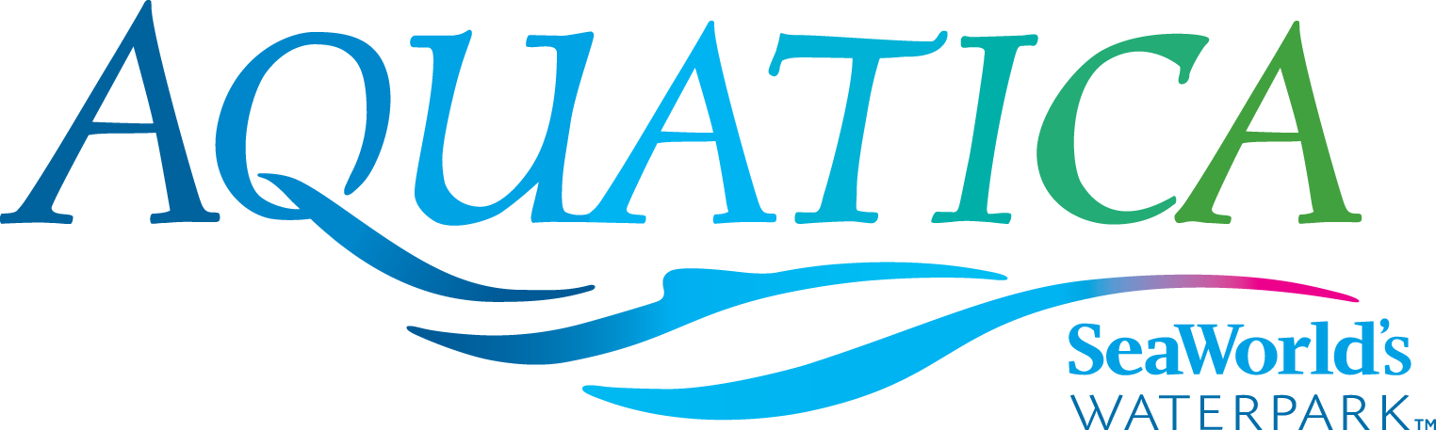

SPLISH SPLASH
WITH AQUATICA’S SEASON SPLASH PASS
Save Now with 2017 Splash Pass and Celebrate Aquatica’s 5th birthday
All Summer Long
CHULA VISTA, CALIFORNIA (April 5, 2017) – Waterpark lovers can save now and splash later by purchasing a 2017 Aquatica Splash Pass, offered for a limited time at the same price as single-day admission, $46. With a Splash Pass in hand, guests can celebrate the fifth season of Aquatica SeaWorld’s Waterpark® with unlimited visits all summer long starting May 26. Aquatica has fun for everyone, with opportunities to lounge on sandy beaches, splash and play in heated pools and journey down high-speed water slides, all amongst a lushly landscaped, South Seas-themed, resort-style environment. The 2017 Splash Pass may be purchased online while quantities last at www.AquaticaSanDiego.com.
Aquatica is like no other waterpark, combining high-speed thrills with the amenities of a beachside resort and up-close animal experiences. For those who like life in the fast lane, the Taumata Racer high-speed water slide zooms riders down a 375-foot slide, around a 180-degree swooping turn, and in and out of tunnels before racing them across a finish line. Among dozens of other slides and attractions are Big Surf Shores, one of the largest wave pools in Southern California; HooRoo Run®, which takes riders down an 80-foot descent; and several children’s attractions including Loggerhead Lane and Slippity Dippity. Caribbean flamingos and freshwater turtles round out the Aquatica experience, as only SeaWorld can.
Located at 2052 Entertainment Circle in Chula Vista, Aquatica is operational daily
May 26–Aug. 27, Aug. 31-Sept. 4, and weekends Sept. 9–Oct. 8. Single-day admission is $46 for ages 10 and older; $40 for ages 3–9. A season Splash Pass costs $46 and does not include parking; a premium season Aquatica Pass costs $89 and includes admission, parking, and discounts on food and merchandise. For more information visit www.AquaticaSanDiego.com or call (619) 222-4SEA.
About SeaWorld Parks & Entertainment
SeaWorld Parks & Entertainment™ is a leading theme park and entertainment company providing experiences that matter and inspiring guests to protect animals and the wild wonders of our world. The company is one of the world’s foremost zoological organizations and a global leader in animal welfare, training, husbandry and veterinary care. The company collectively cares for what it believes is one of the largest zoological collections in the world and has helped lead advances in the care of animals. The company also rescues and rehabilitates marine and terrestrial animals that are ill, injured, orphaned or abandoned, with the goal of returning them to the wild. The SeaWorld® rescue team has helped more than 29,000 animals in need over the last 50 years.
The company owns or licenses a portfolio of recognized brands including SeaWorld, Busch Gardens® and Sea Rescue®. Over its more than 50-year history, the company has built a diversified portfolio of 12 destination and regional theme parks that are grouped in key markets across the United States, many of which showcase its one-of-a-kind zoological collection of over 800 species of animals. The company’s theme parks feature a diverse array of rides, shows and other attractions with broad demographic appeal which deliver memorable experiences and a strong value proposition for its guests. SeaWorld Parks & Entertainment is a wholly owned subsidiary of SeaWorld Entertainment, Inc., a publicly traded company. Visit www.seaworldentertainment.com for more information.
—Aquatica—

