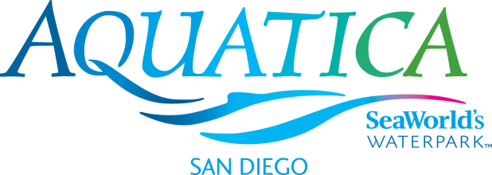

Media: For more information, contact SeaWorld/Aquatica Public Relations at (619) 226-3929.

AQUATICA SAN DIEGO 2017 MEDIA ADMISSIONS POLICY
The media admissions policy for Aquatica SeaWorld’s Waterpark® enables news media to become familiar with the waterpark’s many featured attractions and, at the same time, enjoy a day with family or friends. This courtesy is extended to active, credentialed members of the news media only, which does not include administrative, promotions directors, sales staff or retired personnel, writers of corporate or community newsletters and non-news management. Complimentary admission is available to media in the following categories:
Print Media: Publishers, editors, reporters, writers, photographers
Complimentary admission is provided to freelance writers and producers with written confirmation from the assigning news outlet.
Broadcast Media: News directors, public affairs directors, assignment editors,
producers, on-air personnel (anchors/hosts/DJs/reporters) photographers, program directors
Online media: Bloggers are considered on a case-by-case basis if the blogger
has a significant following and meets other criteria. Links to the blog posts must be sent within seven days of the visit to the park.

A maximum of four complimentary tickets will be granted for a single-day visit within the waterpark’s operating season to qualifying personnel. This courtesy is for park admission only. The 2017 operating season is: daily May 26–Aug. 27, Aug. 31-Sept. 4, and weekends Sept. 9–Oct. 8. The qualifying media representative must arrange for tickets in advance and will receive their print-at-home, turnstile-ready tickets once the request has been processed. Tickets cannot be picked up in advance.
Arrangements for tickets are made by sending us a written request via e-mail (swcpublicrelations@seaworld.com) on your company letterhead, at least 72 hours in advance of your visit. Please attach your media credential along with your request. To assist us with our conservation efforts, please refrain from sending requests via fax. Requests for weekend days made after noon on Thursday will not be granted. For holidays observed on Mondays, requests should be made by noon the previous Thursday. Request should include:
- Name and your company title
- The exact date of your visit
- Number of adult and child tickets (ages 3–9) requested (not to exceed four total)
- A contact phone number and an email address
- A copy of your media credential providing proof as a member of the news media
Once your request is received, please allow 48 hours for it to be processed. You should receive an email confirming your visit. Please contact us at (619) 226-3929 if you have not received a confirmation at least 48 hours in advance of your requested visit. For a weekend visit or a holiday observed on a Monday, please contact us by noon the previous Thursday. For more information on requesting tickets, call (619) 226-3929. Office hours are 8:30 a.m. to 5 p.m. (closed on weekends and holidays).
Media on Assignment: News media on assignment must request interviews and photo sessions in advance. This ensures that appropriate park personnel will be available on the day of the visit. All media on assignment must arrive at the security entrance and be escorted during their visit. Without prior approval, family members and friends will not be permitted to accompany media while on assignment.
—Aquatica—

